TheDigitalCardBox System Design and Flowcharts
MVP architecture, APIs, data model, workflows and operational controls
13 October 2026 | Engineering proposal | United States pilot
Scope. A recipient creates a dated event or a time-limited one-off occasion and shares its URL directly or as a QR. A guest may contribute within the allowed event window and optionally send cash. At day 90, wedding pages become gift-only until month 12; then all guest actions close while the host retains CardVault access and export. Book tiers use final included entries without requiring a guest list. The first pilot uses external wallet handoff; integrated gifts require written provider approval.
Core decision. Maintain one TypeScript repository with orthogonal identity, event, card, AI, gift and book modules. The local starter uses React and Vite for the clickable UI. The Cloudflare demo serves only built static assets from digitalcardbox-app and provides no server validation; its hosting configuration does not decide the production backend. Select the production server approach by 14 October: Next.js route handlers or React with Cloudflare Functions; neither choice changes domain contracts. Event and gift state belongs in a server database, media in private object storage and secrets on the server. Host authentication and guest access are checked at every server boundary. A browser redirect never proves that money was sent.
Diagram guide. The next section puts the backend module design and three flow diagrams first: module boundaries, guest card creation, and the cash gift boundary. The detailed API, data model and operational controls follow.

October 2026 delivery alignment
TheDigitalCardBox is the working product name. The 31 October target is a private external-wallet MVP with manual cards, editable guided AI choices, photo intake, host auth, event link and QR, private CardVault, server-enforced time windows and multi-service guest payee review. Generated backgrounds, licensed music, paid checkout and integrated gift processing are later gates. The diagrams describe the broader architecture; deploy only the tested October slice.

Orthogonal backend architecture
Orthogonal here means that event setup, social content, AI assistance and gifting have separate domain rules and data ownership. A note can be submitted without a gift; a gift can be sent without a note; AI can fail without blocking a manual card; and a payment delay does not erase a submitted note. Keep this as a modular monolith for the MVP, with one deployable repository and a separate worker process.
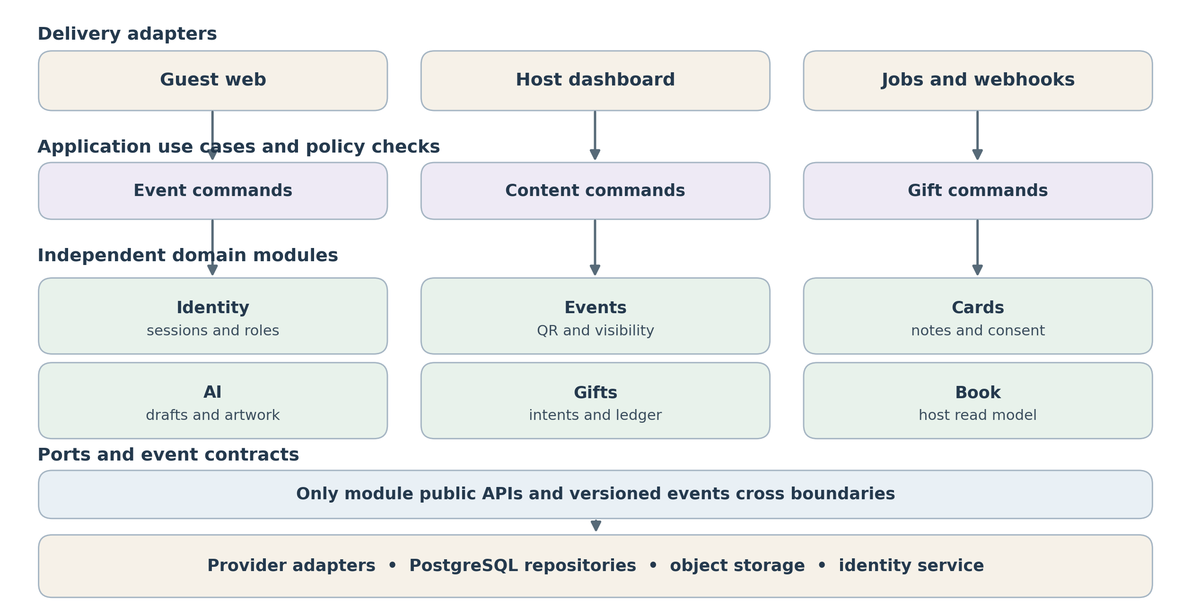
Figure 1 Dependency direction and module boundaries
Each module exports commands, queries and versioned events through a small public API. HTTP routes and jobs call application use cases, which use domain policy and ports. Infrastructure adapters implement those ports. A domain module must not import another module’s internal tables, ORM models or payment SDK. Event IDs, card IDs and gift IDs are opaque references; a host-only read model joins approved data for the dashboard.
Module | Owns | Public contract and failure boundary
Identity | Host accounts, guest sessions and authorization policy. | authenticateHost, requireEventRole and issueGuestSession; deny cross-event reads.
Events | Event/occasion, owner, opaque slug, revocation, event time zone and contribution/gift windows. | publishEvent, getGuestAccess and EventContributionsClosed; server policy owns dates and guest permissions.
Cards | Notes, guest photos, designs, consent and moderation. | submitCard; CardSubmitted. Optional artAssetId; giftId never required.
AI | Text generations, art jobs, budgets and provider prompts. | generateNoteOptions and requestArtwork; ArtworkReady or ArtworkFailed.
Gifts | External intents, integrated ledger, provider status and reconciliation. | createGiftIntent and applyVerifiedWebhook; GiftSettled or GiftDisputed.
Book | Host dashboard projections and private export. | buildEventBook from consented entries; count included entries and quote $15/$30/$79 only after day 90. Basic host export remains.
Music (conditional) | Licensed catalog metadata, rights policy, guest selections and playback eligibility. | selectClip and authorizePlayback; ClipUnavailable. No Cards or Gifts provider SDK dependency.

Backend code structure and dependency rules
Proposed folders: src/modules/{identity,events,cards,ai,gifts,book,music}/{domain,application,ports,adapters,public.ts}; src/entrypoints/{api,workers}; src/shared/{ids,money,clock,errors}; src/infrastructure/{db,outbox,storage}. Each module owns its migrations and repository; shared contains primitives, not event-specific behavior. Controllers do parsing and response mapping; use cases perform authorization, transactions and calls to ports. Wire concrete adapters only at composition root.
Cross-module coordination uses an application workflow and transactional outbox. Cards commits a final note and CardSubmitted in one transaction; Book consumes it into a read model. Events emits EventContributionsClosed at the day-90 boundary so Book can finalize an eligible snapshot and price. Gifts uses Events' public access policy before creating new intents, yet verified callbacks for older intents still reconcile after closure. A gift references an optional card ID but does not fetch card text to process money. Webhooks update only Gifts and publish GiftSettled. Use versions, idempotent consumers and replay tests.

Guest card creation flowchart
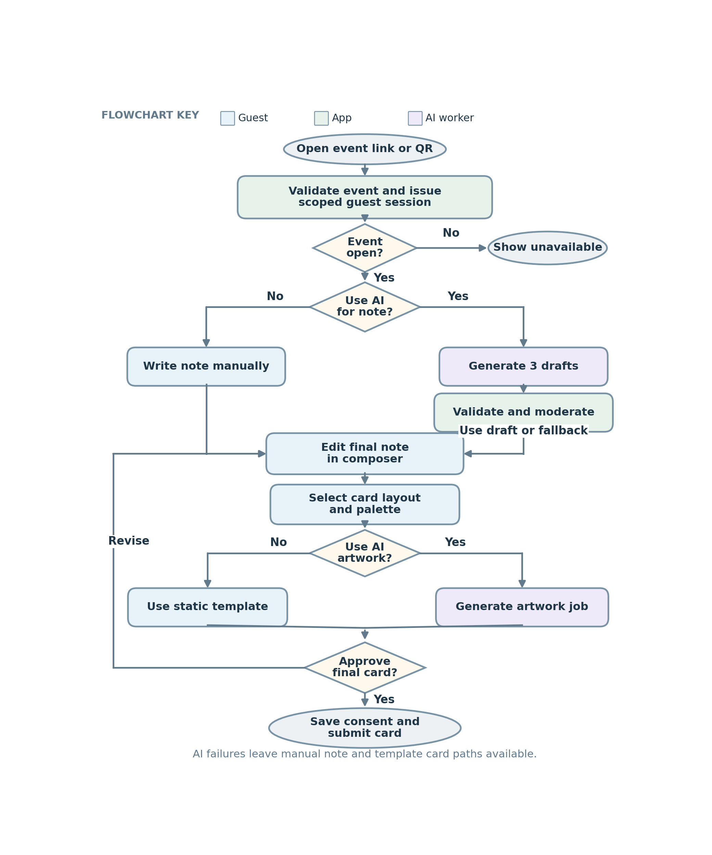
Figure 2 Guest card creation flowchart with decisions and failure paths
The guest session authorizes AI jobs and a final card only while contributions are open. A wedding gift-only page bypasses the card editor and permits only a new gift intent through month 12. The submit-card command stores consent and emits CardSubmitted; a gift starts a separate idempotent workflow. A closed page rejects new writes at the server.

Gift payment and verification flowchart
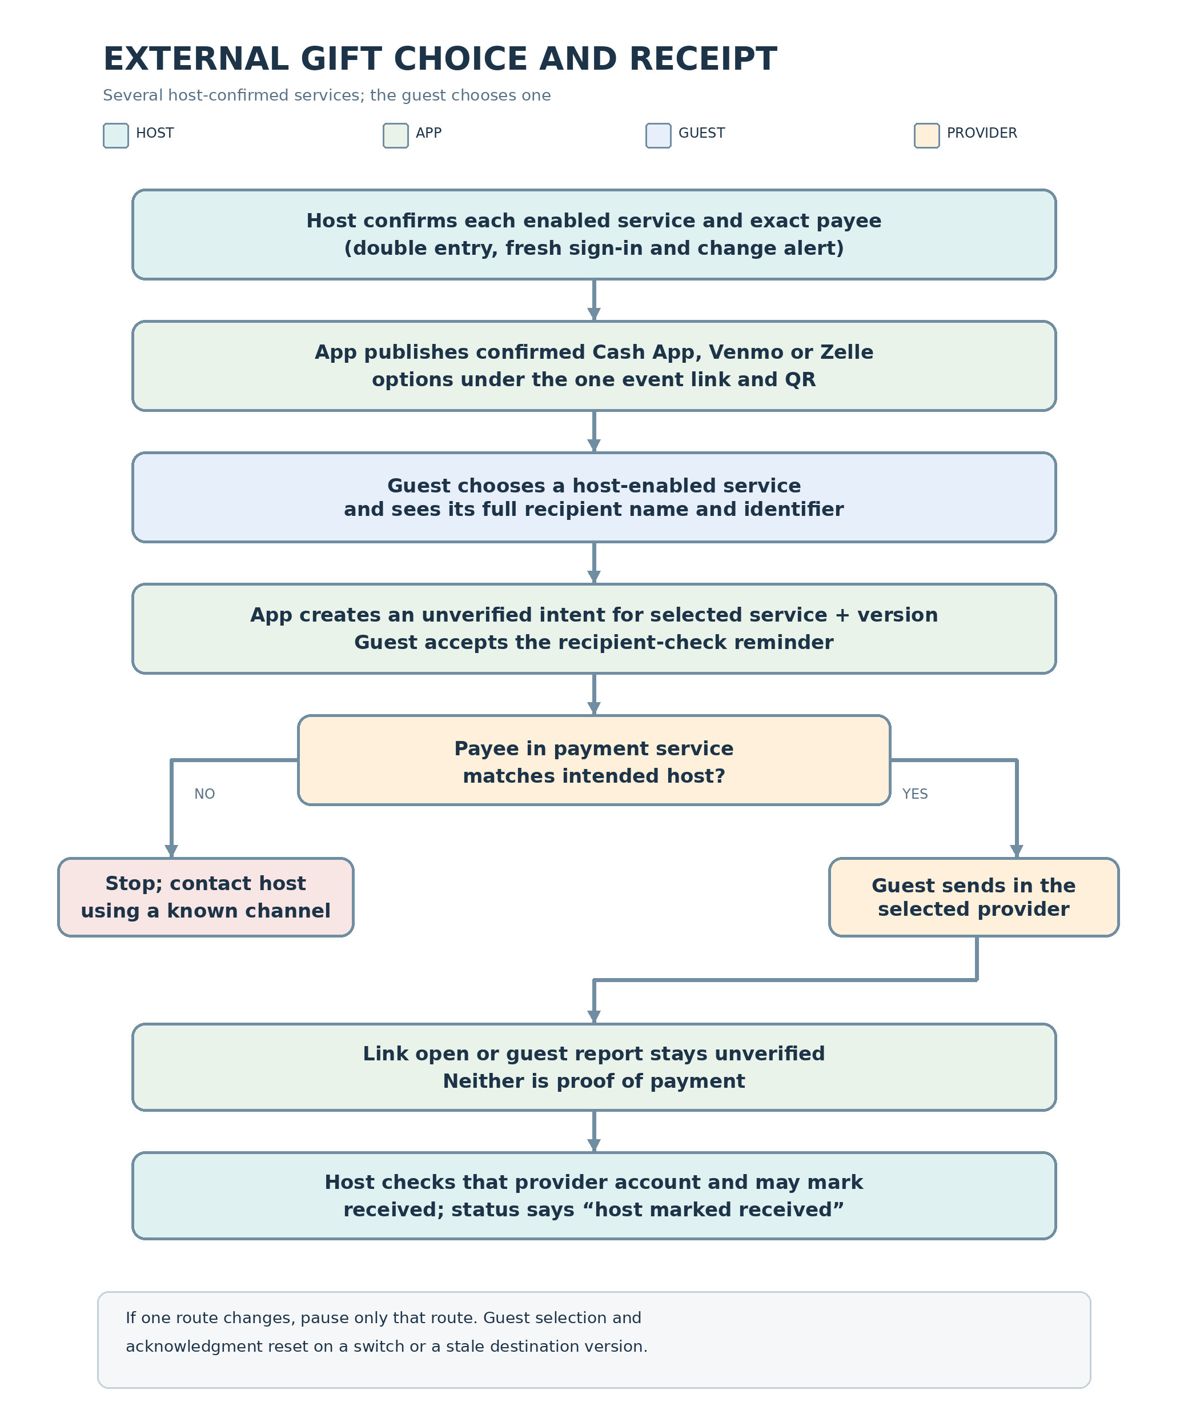
Figure 3 External pilot service choice, destination checks and host receipt flow
The host may enable Cash App, Venmo and Zelle together, with one confirmed destination per service. The guest chooses among currently enabled services, sees the selected full details, and checks the payee inside that service. Changing or disabling one route pauses only that route; switching methods resets the guest acknowledgment. A redirect cannot prove receipt; only the host can mark it received after checking the selected provider account. Integrated gifts require a separate approved route.

User journeys and AI choice
Journey | Input | Result and control
Host setup | Occasion, names, date, privacy, one or more external services, each with an exact destination entered twice and confirmed by host. | One stable URL/QR. Gifts stay off until a route is confirmed; editing one route requires fresh auth, alert and new version, and pauses that service only.
Guest note | Write myself or Help me write; relationship, tone, length, optional memory or open detail. | Three short alternatives; select and edit final text before submission.
Guest card | Choose layout and palette; optional artwork motif or custom art description. | Instant template or up to two generated background variations; app places text over image.
Guest gift | Amount and choice among the host-enabled payment services. | Guest reviews full host supplied destination for the selected service, then checks the payee in the payment service. Handoff remains unconfirmed until host checks receipt.
Host book | Moderated notes, consented media and private gift ledger. | Exportable dated book; gift amounts visible only to hosts.
Optional song | Choose No song or licensed catalog clip after card artwork. | Select catalog ID and preview after tap; view-time rights check. Never block note or gift.

The AI path is guided by default, with an optional open text field. The model receives factual fields as data, never as trusted instructions. It must avoid fabricating shared memories. When details are sparse, it writes a general message. No draft is sent automatically; the guest edits and approves it. The manual composer remains available throughout.

Runtime components and trust boundaries
Layer | Responsibility | Boundary
Browser | Mobile event pages, local draft state, status polling, accessible card preview. | Untrusted; cannot mark gifts settled.
Server routes or Functions | Input validation, host and guest authorization, rate limits, orchestration, signed URLs. | Only server routes read provider credentials.
PostgreSQL | October: customers, event guests, events, submissions/consent, AI usage, destination versions, external gift activity, book/export metadata and audit/outbox. Provider payment and recipient-account tables are later gated extensions. | Private tables and row level access by host.
Object storage | Guest photos and generated card backgrounds. | Private bucket; short lived signed reads and writes.
Worker and queue | Image jobs, email, export, reconciliation and retriable provider calls. | At least once delivery; handlers idempotent.
AI adapter | Structured text options, image generation and moderation. | Budgeted, rate limited, no arbitrary tools.
Payment adapter | External handoff metadata or approved checkout, webhook verification, payout status. | Provider is source of truth for integrated funds.

Start with a small job table in PostgreSQL and a scheduled worker or managed queue. Move to a dedicated queue only when job volume and latency justify it. Keep card text and art independent so guests can keep writing while an image is being created. A static template is always an immediate fallback.

Workflow one event creation and QR access
Step | Client or server action | Stored state or response
1 | Recipient signs in and POSTs event or occasion details to the server. | Page is draft with unique unguessable slug; recipient owns it.
2 | Host enters each selected service and identifier twice, reviews the payee in that service, and confirms ownership. Gifts remain off on mismatch. | Server stores a versioned, host confirmed destination per service; no arbitrary payment URL and no bank credentials.
3 | Server validates configuration and generates a stable opaque public URL and optional QR asset. | Event may publish with gifts disabled; guest gift actions require a confirmed enabled route.
4 | Gift giver opens shared URL or scans QR. Public GET returns safe event fields and an event scoped anonymous session. | Access policy returns active, wedding gift-only, scheduled or closed. Only approved public fields; no host or payout details.

The QR encodes only the stable event URL, never a wallet identifier. Server policy reads the event time zone and permitted window on every request, so links and QR close together. A note-only event may publish without gifts. Publish gift actions only after the host confirms at least one service destination; the host may enable any subset of Cash App, Venmo and Zelle. A change requires fresh host authentication, exact re-entry, a before-and-after review, a host alert, a new destination version and disabled gift handoffs for that service until its new version is confirmed; other confirmed services remain available. Keep an audit history and show guests only the latest confirmed enabled options and the exact destination for their selected service; never silently redirect a printed QR to a different payee.

Event lifecycle and book closing flowchart
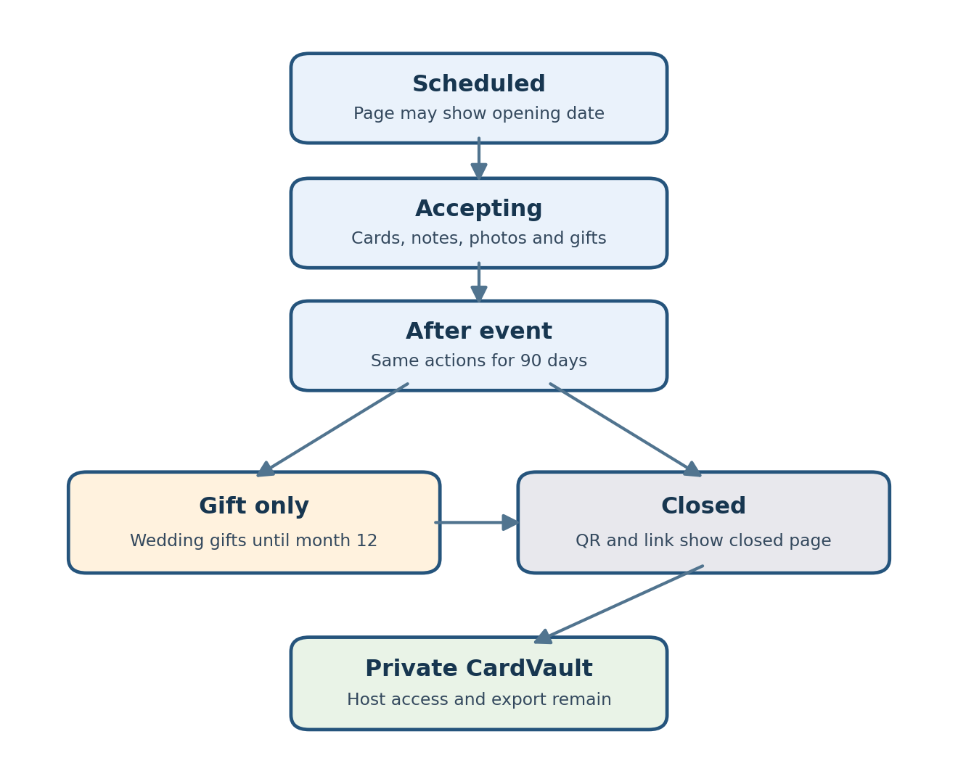
Figure 4 Server controlled event windows and private host access
Host chooses an opening within six calendar months before the dated event. Contributions and gifts run through day 90 after the event; then only a wedding may accept new gifts without card/book entries until month 12. An undated one-off occasion needs a close date within 90 days after publication. After final close, link and QR render the closed page. The host retains CardVault and basic export. Use the event time zone; enforce at the server on every write and quote the polished book after the entry window closes.

Workflow two AI note options
Step | Backend operation | Failure or safeguard
1 | POST /api/events/{id}/ai/notes accepts relationship, tone, length and optional 500 character detail. | Validate event-scoped session and contribution window before spending AI tokens; apply quotas.
2 | Moderate user detail and construct a versioned prompt with event facts and a strict three option schema. | Reject abusive input; do not treat user detail as system text.
3 | Call a text model through the AI adapter and parse structured output. | Timeout, refusal or invalid content returns manual composer and a retry option.
4 | Validate length, uniqueness, invented factual claims when detectable, and output moderation. | Do not assume schema validity implies factual accuracy.
5 | Return three drafts with opaque generation ID. The browser applies the selected draft to an editable text field. | Only guest approved final text is committed as a card.
6 | On submit, validate and moderate final guest text again. | Persist approved content and audit consent.

A practical strict output shape is {options: [{id, text, tone} × 3]}. The service validates the response with the same server schema used by the API. Keep the system prompt stable and versioned; avoid adding previous guest messages or private event data to make output feel personalized. A guest supplied memory is the primary personalization signal. [1][2]

Workflow three artwork generation and card assembly
Step | Backend operation | Failure or safeguard
1 | Guest selects layout, palette, motif, and optional short art detail. POST /api/events/{id}/ai/art creates a job. | Only one active job and two variations per session.
2 | Worker moderates detail, assembles prompt for background art without lettering, then calls image generation. | If model rejects or times out, keep selectable template.
3 | Worker checks file type, dimensions, size and moderation, then writes to private object storage. | No direct public object URL; job status is completed or failed.
4 | Client polls GET /api/ai/jobs/{id} and previews an approved asset through a signed URL. | Return only job owned by event scoped session.
5 | Client renders title and note in HTML or SVG overlay with controlled font and contrast; server exports same composition. | Precise names and text stay editable and legible.
6 | POST /api/events/{id}/cards commits asset ID, style JSON, final note and visibility consent. | Reject at or after the server contribution close; never create cards in gift-only or closed state.

Use a low or medium 1024 × 1024 image for a pilot draft, then measure latency, output tokens and acceptance rate. The OpenAI Image API supports direct prompt generation. Its documented latency can reach two minutes and text rendering may be imprecise, which motivates the independent typography layer. Image access and verification must be checked before promising this feature to pilot hosts. [3]

Workflow four cash gift and reconciliation
External pilot: the host can enable any subset of Cash App, Venmo and Zelle, with one active destination per service. Each route requires the identifier entered twice, review of the payee in that service, and host ownership confirmation. The server accepts an allowlisted service and structured identifier, generates any supported outbound service URL itself, and rejects arbitrary host supplied redirects. Editing or disabling a route immediately removes that choice from new handoffs while other confirmed routes remain available. Fresh host authentication, before-and-after review, versioning, audit and a change alert protect each update. POST /api/events/{id}/gifts takes selected_service and destination_id/version, validates event, service, active route and current version atomically, and returns the exact selected details plus handoff metadata. The guest sees recipient name, service and full identifier; acceptance resets on a service switch or version change. They check the recipient inside the provider and stop on a mismatch. A link open or guest report is not proof of payment; the host checks the selected provider before marking received. Wedding gift-only and final closure rules still apply.
Integrated route: the server checks recipient onboarding, creates a provider payment attempt using a unique idempotency key, and returns a hosted checkout token. The provider webhook signature is verified server side. Each event ID is stored uniquely before applying transitions. Only provider confirmed available funds contribute to the host available total. Payout transitions are separate from gift authorization. Failed, refunded and disputed payments remain in history with compensating ledger entries.
State machine | Allowed transitions | UI label
External | created → handoff_issued; guest_reported remains unconfirmed; owning host may append host_confirmed or host_confirmation_revoked; cancellation is recorded separately. | Link opened and guest reported are unverified. A host who checked their account may mark host confirmed; never label provider verified.
Integrated | created → pending → settled → payout_pending → paid_out; pending → failed; settled or paid_out → refunded or disputed. | Use provider backed language: pending, received, paid out, refunded or disputed.
Card content | draft → submitted → hidden or removed; hidden → submitted after review. | Visible only under guest consent and host moderation.

Provider contract review must define merchant of record, custody, underwriting, fees, refunds, chargeback liability and payout timing. Do not implement the integrated path with ordinary peer to peer Stripe processing without written approval. For the external route, platform and wallet status remain separate. [4][5]

Workflow five host moderation and event book
The dashboard has message/media counts and privately verified gift totals. Moderation controls which consented entries appear in Book. After day 90 no new entries are accepted, and the host can preview a frozen polished book, receive a server-side price quote from its included entry count, and buy it through standalone hosted checkout. The basic CardVault and raw export remain available without buying. A short-lived private export records requester and snapshot. Removal requests affect later exports subject to required financial retention.

API surface and access rules
Endpoint | Input and output | Caller and control
POST /api/events | Event or occasion data → page ID and opaque slug. | Authenticated host; CSRF and validation.
POST /api/events/{id}/publish | Event readiness and optional route configuration → share URL and QR. | Host only; gifts optional, and enabled gift actions require a confirmed route.
POST /api/events/{id}/ai/notes | Selections and optional detail → three drafts. | Guest session plus server contribution-window check; gift-only and closed states reject without AI spend.
POST /api/events/{id}/ai/art | Art settings → job ID. | Guest session, quota and contribution-window check; no art jobs after day 90.
GET /api/ai/jobs/{id} | Job state → signed preview URL if complete. | Owning session; short cache.
POST /api/events/{id}/cards | Final note, style, asset and consent → card ID. | Guest scoped, consent checked and active contribution window enforced server-side.
POST /api/events/{id}/gifts | Amount, selected_service, destination_id/version shown, optional card ID and idempotency key → external intent and handoff metadata. | Guest scoped; active or wedding gift-only only. Require guest destination acknowledgement; reject cross-event, disabled, stale or unconfirmed route/version and a missing acknowledgment for the selected service.
POST /api/payment/webhook | Signed provider event → 2xx after durable record. | Provider only; unique event ID and replay safe.
GET /api/events/{id}/dashboard | Cards, private gifts and exceptions. | Host only; no public gift amounts.
POST /api/events/{id}/exports | Export request → job ID and eventual signed URL. | Host only; audited.
PUT /api/events/{id}/gift-destinations/{service} | Selected service, recipient display name, repeated exact identifier and enabled state → destination version after host confirmation. | Host only; fresh authentication, strict format and service allowlist, audit, alert; only that service pauses during edits; other confirmed options stay active.

The URL paths are proposed contracts. Use a schema validator on both client and server, UUID primary keys, cents as integer amounts, ISO currency, and explicit API error codes. All state changing calls accept idempotency keys or deduplicate against a request ID. Paginate lists; bound media size and generated text length.

Database tables and relationships
October table | Key columns (shared IDs/timestamps per canonical spec) | Constraint / purpose
identity.customers | id, auth_issuer, auth_subject, email, email_verified_at?, display_name, account_role, disabled_at? | PK id; UQ (auth_issuer, auth_subject). Role host or separately provisioned operator; provider-synchronized email is for notifications, not an ownership key. No passwords/MFA secrets.
identity.event_guests | id, event_id, display_name?, erased_at? | PK id; FK event; UQ (event_id, id). The only guest profile; no global guest list or matching by email/name. Separate browsers may be separate anonymous guests; this is not a verified person count.
identity.guest_sessions | id, event_id, guest_id, share_link_id, token_hash, expires_at, revoked_at? | PK id; UQ token_hash; same-event composite FKs to guest and share link. Store only token hash; bearer secret stays in a secure cookie. Index expiry. Durable content references guest, so deleting sessions cannot erase accepted data.
events.events | id, owner_customer_id, title, recipient_display_name, occasion_type, lifecycle_kind, event_date?, timezone, opens_at, contributions_close_at, gifts_close_at, published_at?, revoked_at?, window_locked_at?, policy_version | PK id; FK customer; index (owner_customer_id, created_at, id). Kind wedding/dated_other/undated; occasion labels do not grant wedding extensions. Check ordered windows and date/kind consistency. Events alone derives deadlines.
events.share_links | id, event_id, generation, token_hash, token_ciphertext, encryption_key_version, revoked_at? | PK id; UQ token_hash, (event_id, generation), (event_id, id); partial UQ one unrevoked link per event. Encrypt recoverable secret for repeated host copy/QR; resolve URLs by hash. Rotation revokes old links and their guest sessions.
cards.submissions | id, event_id, guest_id, kind, text, template_key?, template_version?, style_json?, submitted_at?, content_state, removed_at? | PK id; same-event guest FK; UQ (event_id, id). Kind note/card; state draft/submitted/hidden/removed. Template/version required for styled card. One submission is one book entry; no required gift reference. Index (event_id, submitted_at, id).
cards.media_assets | id, event_id, guest_id, submission_id?, object_key, mime_type, byte_size, width, height, scan_state, deleted_at? | PK id; UQ object_key; same-event guest/submission FKs. Partial UQ submission_id when attached and not deleted enforces one photo. Positive bounded size/dimensions, allowlisted type, clean guest-owned attachment only. Private keys, not file bytes or signed URLs.
cards.consent_events | id, event_id, submission_id, sequence, guest_id?, choice, wording_version, recorded_at | PK id; UQ (submission_id, sequence); same-event submission/actor FKs. Choice private/book_allowed/withdrawn. Latest ordered event is authoritative; explicit choice required, missing consent denies book inclusion. No duplicate consent booleans in each source table.
cards.moderation_actions | id, event_id, submission_id, sequence, actor_customer_id, action, reason_code?, recorded_at | PK id; UQ (submission_id, sequence); scoped submission FK, customer FK. Append hide/restore/remove evidence while atomically changing submissions.content_state as indexed current state. No private text in reason codes.
ai.requests | id, event_id, guest_id, request_key, kind, prompt_version, model, status, input_tokens, output_tokens, image_count, estimated_cost_micro_units?, cost_currency?, completed_at?, error_code? | PK id; same-event guest FK; UQ (event_id, guest_id, request_key). Minimal usage/outcome metadata; optional spend estimate uses millionths of currency units to retain sub-cent precision. No durable private prompt/suggestion copies; guest-approved text belongs to Cards. Art extends this only after its gate.
ai.usage_buckets | scope_type, scope_id, period_start, request_count, reserved_units, used_units, expires_at | PK (scope_type, scope_id, period_start). Guest/event/application budget scopes; atomic reservation before spend. Settle/release reservations on success/failure with bounded crash recovery. Counters are derived quota state, not a billing ledger.
gifts.routes | id, event_id, service, current_version, enabled | PK id; UQ (event_id, service), (event_id, id, service), (event_id, id). Service allowlist Cash App/Venmo/Zelle. Deferred composite FK (event_id, id, current_version) to destination_versions, added after both tables exist. One stable slot per service; no plaintext identifier copy.
gifts.destination_versions | route_id, event_id, version, recipient_display_name, identifier_kind, identifier_ciphertext, encryption_key_version, created_by_customer_id, host_confirmed_by_customer_id?, host_confirmed_at?, confirmation_wording_version? | PK (route_id, version); UQ (event_id, route_id, version); same-event route FK and actor FKs. Incrementing version; identifier kind valid for route's service. Identifier/name immutable; confirmation set once after authorized double-entry/service review. No stored second entry or arbitrary URL.
gifts.gift_intents | id, event_id, guest_id, selected_service, destination_id, destination_version, review_revision, acknowledged_revision?, acknowledged_at?, acknowledgment_wording_version?, intended_amount_minor?, currency?, request_key, cancelled_at? | PK id; UQ (event_id, guest_id, request_key), (event_id, id). destination_id is route ID; composite FKs to same-event guest, (event_id, destination_id, selected_service) route and (event_id, destination_id, destination_version) version. Amount/currency both absent or both valid. No mandatory card ID.
gifts.gift_events | id, event_id, gift_intent_id, sequence, type, destination_id, destination_version, review_revision, actor_guest_id?, actor_customer_id?, request_key, recorded_at | PK id; UQ (gift_intent_id, sequence), (gift_intent_id, request_key); scoped intent/version/actor FKs. Append handoff_issued, guest_reported, host_confirmed, host_confirmation_revoked, cancelled. Public use cases enforce actor rules; only owning host confirms/revokes receipt. Preserve historical reviewed tuple.
book.entry_projection | event_id, submission_id, source_revision, eligible, submitted_at, sort_key | PK (event_id, submission_id); scoped submission FK. Rebuild from Cards public events/query; no duplicate text, photo, guest profile or gift amounts. Index (event_id, eligible, sort_key, submission_id).
book.snapshots | id, event_id, revision, cutoff_at, included_count, finalized_at | PK id; UQ (event_id, revision), (event_id, id). Nonnegative count derives from entries in same transaction. No new entries after contribution close; correction revisions may remove entries without admitting late gifts.
book.snapshot_entries | event_id, snapshot_id, submission_id, position, source_revision | PK (snapshot_id, submission_id); UQ (snapshot_id, position); same-event snapshot/submission FKs. Frozen membership/order, not another content store.
book.exports | id, event_id, snapshot_id, requested_by_customer_id, request_key, status, object_key?, expires_at, invalidated_at?, completed_at? | PK id; UQ (event_id, requested_by_customer_id, request_key); scoped snapshot/customer FKs. Private object, newly issued short-lived signed URL, audited access. Worker/download reauthorize ownership and current consent/moderation; stale projection cannot authorize disclosure.
platform.audit_events | id, event_id?, actor_kind, actor_id?, module, action, entity_id, entity_revision?, request_id, outcome, recorded_at | PK id; append-only to runtime; index (event_id, recorded_at, id). Sensitive actions/destination edits/exports contain IDs and versions, no clear identifiers, tokens, card text or request payload.
platform.idempotency_keys | actor_scope, operation, request_key, request_digest, resource_id?, status, expires_at | PK (actor_scope, operation, request_key); server-derived scope includes event. Same key/body resolves previous resource, different body conflicts. No cached secret URL/decrypted destination. Handoff retry still rechecks validity; deduplication cannot bypass closure/revocation.
platform.outbox_messages | id, event_id?, module, entity_id, entity_revision, type, payload_json, available_at, attempts, lease_until?, processed_at? | PK id; UQ (module, entity_id, entity_revision, type); pending-work index. Mutation/public event commit together; bounded leases/backoff/retries preserve failures for review. Payload contains minimal IDs/revisions, no private text/identifier.
platform.consumer_receipts | consumer, message_id, processed_at | PK (consumer, message_id); FK retained outbox ID. Projection update and receipt commit together; source revisions prevent duplicate/out-of-order changes. Keep receipts as long as messages can replay.

Use database transactions for gift state changes and outbox job creation. Financial reporting should derive from provider confirmed events and explicit ledger rows, not from editable card fields. Row level policies are a second defense behind server authorization. Never allow a public client to update gift states directly.

Suggested code organization
Area | Modules and responsibilities
app routes | app/e/[slug] guest pages; app/host/events/[id] host pages; app/api routes thin controllers.
domain | events, cards, ai, gifts, payments, book, exports: state machines, date and pricing policies.
adapters | db, storage, ai, payment, email interfaces and vendor implementations.
workers | image generation, email, reconciliation, export and retry runner.
shared | Zod or equivalent schemas, error codes, date and money types; no server secrets in shared bundle.
tests | Unit tests for event boundaries and tiers; integration tests for guest gating, webhook replay and host access.

Keep controller logic small: parse request, authenticate, authorize, call a domain service, serialize response. Depend on an interface for AI and payment providers so provider changes do not rewrite event logic. The system can remain one deployable codebase at MVP scale while workers run separately.

Authentication authorization and session design
Host accounts use a managed identity provider and verified email. Prefer passkeys or multifactor sign in; do not build a password database for the MVP. Require fresh authentication before publishing or changing a payment destination, adding a host or downloading a private book. A destination edit also requires re-entry and confirmation, records old and new version, sends a change alert, and pauses new handoffs for that service until confirmed, while other confirmed services remain available. Operators have separate roles and mandatory multifactor authentication. [7][8]
Actor | Sign in and session | Server access policy
Host | Verified email through managed identity; opaque server session in Secure, HttpOnly, SameSite cookie. Rotate at sign in; idle and absolute expiry; logout revokes. | Every host route checks authenticated user and event ownership or explicit event membership. Reauthenticate for sensitive changes.
Guest | No account required for a first note. Server issues a random event scoped anonymous session in a protected cookie; store only token hash and expiry. | Can create and edit only own draft during active session. Public QR grants access to public event fields, never dashboard, payout data or other guests’ private drafts.
Operator | Separate privileged account with multifactor authentication and restricted operational roles. | Access only necessary events and payment exceptions; audited access and no routine access to private notes.
Provider webhook | No human sign in; endpoint accepts signed provider callbacks over HTTPS. | Validate signature against raw request bytes, deduplicate event ID, apply allowed transitions; no browser can call a settlement transition.

Authorization is enforced in a central server policy on every read, write, export, media URL and job status lookup. Derive actor and event from validated session and database ownership; do not trust owner_id, event_id or role values supplied by the browser. Use CSRF tokens or strict Origin checking for cookie authenticated writes, a restrictive Content Security Policy, output escaping, upload scanning, dependency updates and rate limits. Test cross event access, expired sessions and privilege changes. [7][8]

Provider handled payment and payout data
External pilot: the host may supply one active Cash App, Venmo and Zelle identifier each, but no account credentials. They can enable one, two or three services. For Zelle, an enrolled email or phone is personal information that needs access control; use a supported tag only where available. For every route the app stores service, exact identifier, host supplied recipient name, confirmation timestamp, active state, version and audit history, but no bank account, card details or password. Only confirmed enabled routes appear to a giver, who chooses a service, sees its exact details and checks the payee shown by that service. A choice change resets their acknowledgment. We cannot verify ownership merely because the host entered an identifier, infer receipt from a redirect, or reverse a transfer. Host marking is labeled host confirmed, not provider verified; do not store receipt screenshots as proof. Adjacent copy says the host supplied the selected destination and the app does not process or verify the gift. Terms can allocate host/guest input responsibility to the extent permitted by law, but cannot guarantee immunity for our own errors. Have counsel review terms and on-screen copy before launch. [13][14][15]
Integrated route, only after provider approval: server creates a checkout session for the chosen amount and redirects the guest to the provider hosted payment page. The guest types card or bank details on the provider domain, not an application controlled form. Recipient identity verification and payout bank entry happen through provider hosted onboarding. Our application stores provider account and checkout IDs, amounts, currency, fees, minimal status, timestamps and ledger records. It must not receive or persist PAN, CVV, account and routing numbers, identity document images, or raw onboarding form answers. [9][10][11]
Data | Collected by | Stored by this application
Host login email and role | Identity provider and application | Verified email, provider subject ID, role and audit trail.
Guest name, note and photo | Application | Only submitted content and consent; private assets with retention and deletion controls.
External gift destination and amount | Host supplies each enabled identifier; application records intended amount, selected service and destination ID/version | Exact host supplied payee identifier for each enabled service, host confirmation, event and unconfirmed or host marked status. No proof of transfer.
Guest card or bank credentials | Payment provider hosted checkout | Never in app forms, logs, database, analytics, error reports or support tickets.
Host payout bank and identity documents | Payment provider hosted onboarding | Provider account ID and readiness flags only; no bank account number or documents.

Payment flow: guest chooses amount → server validates event and fee, creates idempotent gift intent → provider hosted page receives payment details → signed webhook is durably recorded and reconciled → app updates the gift ledger. A return URL is only a navigation signal, not proof of payment. Provider onboarding completion is verified from provider state, not the browser return. Store an allowlisted subset of webhook fields and a payload digest rather than full personal data in logs. Use encryption in transit and at rest, least privilege database roles, secret rotation and tested backups.
The external path reduces exposure to payment credentials, but wrong host input, account takeover, copied links and faulty app routing can still misdirect a gift. Disclosures must be prominent where a guest acts; do not claim a destination is independently verified or a gift was paid merely because a link was opened. The app still protects accounts, guest content, gift amounts and payment metadata. Any PCI scope for later hosted checkout depends on provider and acquirer assessment. The integrated route requires written acceptance of the exact gifting funds flow. [11][12][13]

Reliability privacy and spending controls
- AI requests: per-session and per-event quotas, input caps, timeouts and a monthly budget switch. A closed or gift-only page rejects note/art requests before calling any model. Log token/image use, latency and prompt version while minimizing private memory retention.
- Content: moderate prompts and outputs, limit image dimensions and upload size, scan files, provide host hide and delete, and prohibit unconsented use of guest media in marketing.
- Payments: verify webhook signatures, preserve raw event digest, reject duplicate event IDs, reconcile daily, separate availability from payout, and give operators a manual exception queue.
- Access: authenticated hosts, scoped guest tokens, short lived signed media URLs, CSRF protection, secure cookies, rate limits and audit logs for export and destination changes.
- Recovery: database backups and restore drill, retry jobs with bounded exponential backoff, dead letter queue, static card fallback and no automatic retries of a failed charge without explicit provider rules.
Suggested pilot service indicators: 99% of non AI event pages load successfully, 95% of note requests return or fail clearly within a measured threshold, every payment webhook is durably recorded once, and the daily reconciliation queue is empty or acknowledged. Set numerical latency targets after a real prototype and provider measurements.

Delivery order and acceptance checks
Build increment | Acceptance check
1 Event and guestbook | Host publishes one URL/QR; time-zone-based windows gate guest actions; host can export privately after close.
2 Guided AI notes | Three distinct options, editable final text, manual path, refusal and quota fallback.
3 AI art | Async job, two variations, safe private assets, deterministic readable overlay and template fallback.
4 External cash | One or more independently confirmed service destinations, guest service picker, double-entry, exact selected-route display and resettable acknowledgement, no arbitrary redirect, change alert/version; external status never falsely provider verified.
5 Integrated cash | Written approval, provider onboarding, checkout, webhooks, refunds, payouts, reconciliation.
6 Pilot hardening | Mobile accessibility, abuse controls, budgets, backups and five supervised events.

AI cost model and source notes
Text example: 1,500 input tokens and 450 output tokens for three options at GPT 6 Luna standard short context rates ($0.10 per million input and $0.50 per million output) equals about $0.000375 per request. The image generation rate is token based and changes with model, size and quality; instrument actual usage and cap variations per guest. These figures exclude any other vendor charges and may change. [6][3]
[1] OpenAI Structured Outputs — https://developers.openai.com/api/docs/guides/structured-outputs
[2] OpenAI Moderation — https://developers.openai.com/api/docs/guides/moderation
[3] OpenAI Image Generation — https://developers.openai.com/api/docs/guides/image-generation
[4] Stripe restricted businesses — https://stripe.com/legal/restricted-businesses
[5] Moov pricing — https://moov.io/pricing/
[6] OpenAI API pricing — https://developers.openai.com/api/docs/pricing
[7] OWASP Authentication Cheat Sheet — https://cheatsheetseries.owasp.org/cheatsheets/Authentication_Cheat_Sheet.html
[8] OWASP Session Management Cheat Sheet — https://cheatsheetseries.owasp.org/cheatsheets/Session_Management_Cheat_Sheet.html
[9] Stripe Checkout hosted page workflow — https://docs.stripe.com/payments/checkout/how-checkout-works
[10] Stripe hosted onboarding — https://docs.stripe.com/connect/hosted-onboarding
[11] Stripe payout account collection — https://docs.stripe.com/connect/payouts-bank-accounts
[12] PCI Security Standards Council SAQ A update — https://blog.pcisecuritystandards.org/important-updates-announced-for-merchants-validating-to-self-assessment-questionnaire-a
[13] FTC guidance on clear disclosures — https://www.ftc.gov/business-guidance/resources/advertising-faqs-guide-small-business
[14] CFPB guidance on payment destination mistakes — https://www.consumerfinance.gov/archive/blog/helpful-tips-using-mobile-payment-services-and-avoiding-risky-mistakes/
[15] Zelle guidance on recipient check — https://www.zellepay.com/faq/i-was-asked-send-money-zelle-tag-small-business

Optional licensed art and music module
Cards owns visual composition and text, AI provides editable note and layout choices in October, and Music owns later licensed playback. Generated artwork is a follow-on experiment after the October gate. No domain module imports a vendor SDK. A static no-song card remains valid on failure.
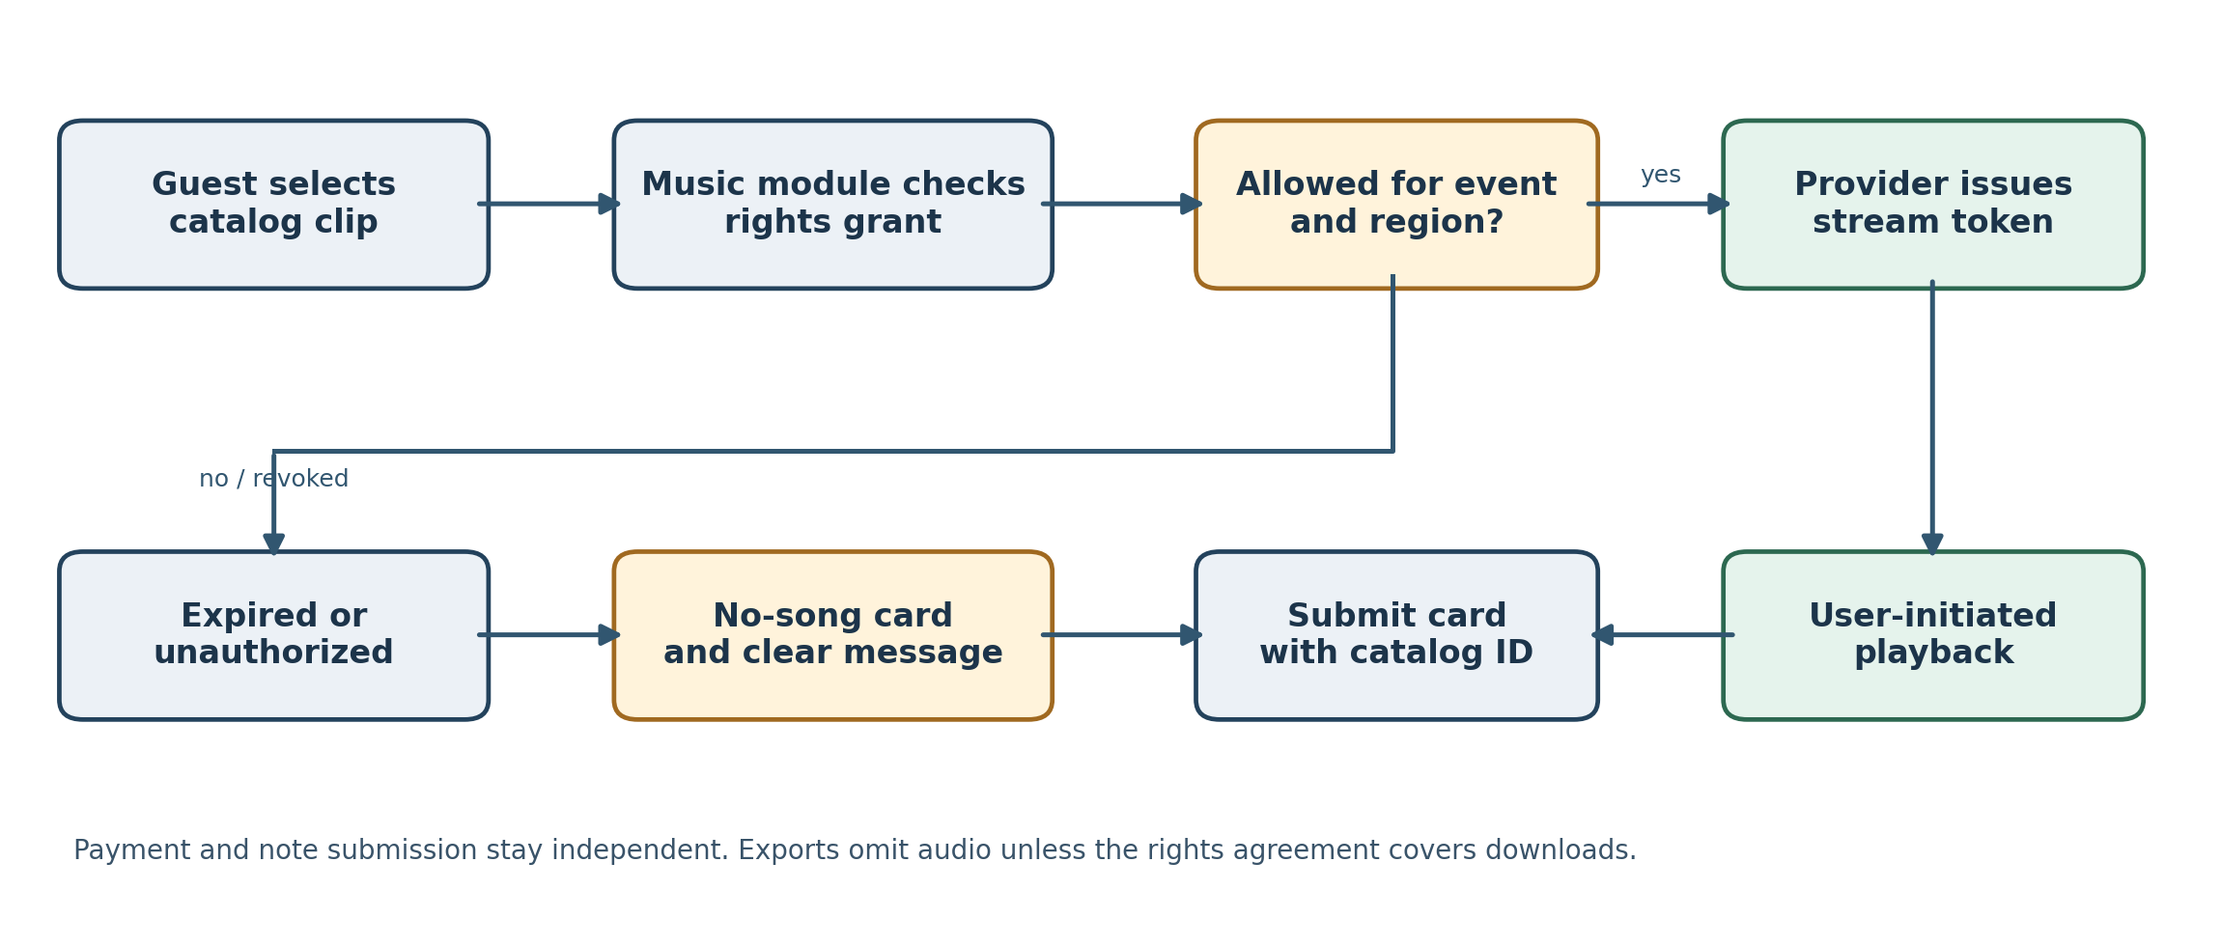
Figure 5 Licensed clip selection and rights decision at playback
Boundary | Owner and data | Failure or rights rule
Artwork procurement | Assets keeps source, creator, permitted use, grant document/version, territory, term and derivative/export scope. Private storage serves approved images. | Standard stock subscriptions are not blanket rights to redistribute card templates; review per-asset license before publishing.
Music adapter | Music stores only catalog identifiers, title/artist, rights metadata, selection and short-lived provider playback token. Vendor hosts the recording. | Validate in-app card/note playback, sharing, region, event-book retention and download/export separately.
Submission | Cards accepts optional musicCatalogId after server-side eligibility check; CardSubmitted carries reference only. | A revoked clip results in silent card plus attribution or removal according to grant; no submission rollback.
Viewing/export | Music authorizes each play using rights version, region, term and provider state; browser starts audio only after user gesture. | No autoplay; export defaults to static art/text. Embed audio only if contract explicitly permits.
Security/operations | Rate-limit catalog/play requests; protect tokens, minimize telemetry, purge expired selections and audit grants. | Do not accept user-uploaded popular-song files or scrape third-party preview URLs.

Proposed API extension: GET /api/events/{id}/music/catalog returns permitted clip metadata to an event-scoped guest; POST /api/events/{id}/music/preview returns a short-lived stream token; POST /api/events/{id}/cards accepts an optional musicCatalogId; GET /api/cards/{id}/music/play rechecks license and issues a stream token. Host export calls Cards and Book without pulling audio by default. Rights changes invalidate cached tokens and switch recipients to a silent view.
Music is a gated phase after the external pilot: 16–28 incremental engineering hours, with a written card/note streaming and sharing agreement before live clips. Outsourced art sourcing needs 8–16 separate product/design hours. Public illustration benchmark US$299–US$1,499 per brief and stock plan US$29.99/month under annual commitment; actual template and music rights need quotes. The October private MVP targets 180 focused hours. The broader external pilot remains 192–215 hours, with 140–220 more for approved integrated gifts, or 332–435 combined. The external phase with music becomes 208–243 hours and the combined route with music becomes 282–440. These estimates retain human security, accessibility and payment-state testing.
Rights sources checked 28 September 2026: https://99designs.com/pricing/illustrations ; https://stock.adobe.com/Plans ; https://stock.adobe.com/license-terms ; https://www.feed.fm/clips ; https://www.copyright.gov/engage/musicians/ . A clip duration alone does not grant permission; a song composition and its recording can require distinct rights. Obtain the exact vendor grant and a quote before release.

Direct sharing and one-off occasion workflow
Step | Server or client behavior | Control
1 Create | Authenticated host selects event kind, date/time zone or one-off close date, title and privacy. Events owns stable opaque slug and derived opening/closing instants. | Dated pages open no earlier than six months before event. Undated one-off close date ≤90 days after publication.
2 Share | Owner copies https://app.example/g/{opaque-slug} or invokes the device share sheet; a QR is generated from that same URL. | No address-book import; preview reveals only approved public title and image.
3 Open | Guest opens URL by text/email/social or QR. Server computes allowed actions: scheduled, contributions open, wedding gift-only or closed. | The public link grants landing access, never dashboard/payout data; note and gift APIs check state.
4 Rotate | Owner disables or regenerates a leaked URL; application records share-token version and invalidates old tokens. | Display a clear unavailable page; do not silently redirect to a new recipient.
5 Give | Guest submits during the permitted window. After day 90, weddings allow gifts only until month 12; after final close both link and QR show closed page. | No guest entry/gift creation after deadline; host CardVault and export continue; existing gift callbacks reconcile.

API/data extension: POST /api/events accepts kind=event|occasion, event date and time zone or an undated one-off close date. POST /share issues the owner-only URL; POST /share/rotate invalidates the old slug; GET /g/{slug} returns public fields and permitted actions. Store opens_at, contributions_close_at, gifts_close_at, share_version and revoked_at. Derive state from server clock in event time zone; reject moving an event date or deadlines after the first entry or gift attempt. QR is a representation of the same URL. Events owns routing and lifecycle; Cards, AI, Book and Gifts call its public access policy.

Premium card and event book purchase boundary
The free external pilot has no in-app premium checkout. A later 12–20-hour commerce increment can use provider-hosted standalone sales for $4.99 premium cards and $15/$30/$79 event books. One consented note or card submission included in the book counts once even with attached photos. Book prices reflect 0–99 / 100–299 / 300+ entries after day-90 close, with no guest capacity preselection or contribution cap. The host previews price and book free; a server-quoted checkout price and signed payment event grant a scoped entitlement. Basic CardVault and export remain. Store purchase ID, included-entry count, tier price, refund and entitlement, never payer card data. Gift payouts remain separate; a return URL alone cannot unlock a book.

Database design and delivery update — 13 October 2026
Canonical decisions: docs/specs/DATA_MODEL.md and ADR 0005. Use one managed PostgreSQL database per environment with private object storage for photos and exports. Evaluate Supabase first; actual provider, version, identity integration and connection adapter remain subject to the ADR 0001 deployment spike. No database/service is provisioned by this planning change.
Store one provider-linked customer identity, anonymous event-scoped guests separate from expiring sessions, unified note/card submissions, explicit consent and moderation history, immutable encrypted gift destination versions, external intent/activity and private book snapshots/exports. Module boundaries remain public contracts with scoped relational keys and short shared transactions. Outbox and deduplication protect accepted writes and host alerts.
External gift activity is unconfirmed unless the host marks a checked receipt; neither a handoff nor a guest report proves payment. Future premium purchase transactions belong to Billing orders/attempts/verified events/entitlements/refunds. Approved integrated gift processing has a separate Gifts ledger/payout/reconciliation design and requires a new provider-approved ADR.
The detailed backlog now has 180 October hours across 54 stories: previous 156 hours plus 24 explicit database-foundation hours in DCB-E18. Weekly totals are 72/54/54, so October 31 requires capacity replanning. The prior 114–157 October and 126–192 broader-pilot ranges are historical; the provisional broader pilot is 192–215 hours (180 + prior 12–35 follow-on allowance), pending overlap review. Do not add the old aggregate database allowance again. The fixed one-time $500 development arrangement and vendor-price assumptions are unchanged.
Existing feature stories own behavior; existing Security stories own encryption and tested database/media restore, published retention and a manual deletion runbook. Database design alone is not implementation or verified transaction history. Guest intake closure does not delete private CardVault records or promise indefinite hosting. Automated deletion and future checkout remain Post-MVP.

Future transaction tables — not October migrations
Future tables | Relations / invariants | Existing story owner
billing.orders, billing.order_items | Buyer customer or same-event guest; item references card or frozen book snapshot. Server quote fixes item price/currency and count/tier. No book_orders copy. | DCB-E10-S02/S03
billing.payment_attempts, billing.provider_events | Attempts FK order; unique provider references/request keys. Event UQ (provider, provider_event_id), verified signature, allowlisted fields/digest. Multiple attempts per order; return URL cannot mark paid. | DCB-E10-S03/S04
billing.entitlements, billing.refunds | Entitlement FK paid item with unique target grant; refund FK attempt and unique provider refund ID. Grant/revoke once from verified state; preserve history and partial/full refunds. | DCB-E10-S04/S05
gifts.recipient_accounts | FK customer, unique provider account ID/readiness; provider collects identity/bank data. | DCB-E11-S02
gifts.integrated_payments, gifts.payment_attempts, gifts.provider_events | Payment FK event/guest/recipient and optional card; separate from external intents. Attempts FK payment; signed events/unique provider IDs, approved state machine. | DCB-E11-S03/S04
gifts.ledger_accounts, gifts.ledger_journals, gifts.ledger_entries | Approved double-entry: journal FK payment/provider event; entries FK journal/account with positive minor units and debit/credit side; currency per account. Balanced journals commit atomically; corrections compensate. Never derive money from external clicks. | DCB-E11-S05/S06
gifts.payouts, gifts.payout_allocations, gifts.refunds, gifts.disputes | Unique provider IDs; allocations link payout to settled payments/journals; refund/dispute FK payment and compensating journal. Distinguish settlement/availability/payout. | DCB-E11-S05/S06
gifts.reconciliation_runs, gifts.reconciliation_items | Run provider/time range; items link unmatched payment/payout/journal and resolution evidence. Daily amount/currency/state matching. | DCB-E11-S07
The preceding October dictionary replaces the older mixed-phase table list. Detailed types, indexes, FK contracts, exact authorization, retention and concurrency evidence are maintained in DATA_MODEL.md. UUIDs and same-event composite references preserve scope; customer email is not an ownership key. Consent, moderation and exports must recheck current exclusions. All five existing drawings and their media remain unchanged.

DEV, TEST and PROD delivery – 13 October 2026
One GitHub repository uses GitHub Actions for static UI delivery. Feature branches create DEV previews under digitalcardbox-app-dev. Develop updates the stable digitalcardbox-app-test Worker, while release branches create separate TEST previews. Only master targets the existing digitalcardbox-app production Worker and customer URL, after the owner’s approval. Master begins from current production history with pipeline files only; feature UI changes are not promoted during setup. The previous main is retained as a frozen legacy reference during cutover.
The repository has one contributor. Required PR approvals are zero, and production deployment self-review is allowed for rcummings713. Build checks remain required. Deleted-branch push events skip jobs so the default-branch fallback cannot select a production deployment. Deployment uses the checked build artifact and rejects an approval when master has moved. Use three distinct account-owned API tokens, one per GitHub environment, with Specified Workers / Individual Workers Editor access only to digitalcardbox-app-dev, digitalcardbox-app-test or digitalcardbox-app respectively. Keep the account ID as a public environment variable and each token as the matching environment secret. No whole-account, domain-route, Pages, KV, R2, Containers or Workers CI policy is required. The owner installed these tokens and DEV/TEST deployment retries succeeded on 13 October 2026. Disable the existing Cloudflare Git-connected automatic builds so they cannot bypass the GitHub approval. The current local Cloudflare session cannot manage API tokens or Builds settings (HTTP 403), so those account settings require the owner’s action.
These are separate static deployment targets, not installed production databases or verified payment services. PostgreSQL and private storage remain environment-specific future work under ADR 0005 and DATA_MODEL.md; the server runtime choice in ADR 0001 stays open. ADR 0006 and planning/ENVIRONMENTS.md record the pipeline, solo release steps and rollback procedure.

21 October 2026 DEV review extension
The isolated feature DEV preview now shares event/card operations through a Cloudflare SQLite Durable Object adapter, while local Node SQLite remains available. QR codes encode the published UI guest URL and are decoded in cross-browser tests. Cookie-owned seven-day host review workspaces and a separate secret-protected operator replace publicly shared hosted test passwords. Managed production identity, PostgreSQL, backups and production retention remain open. No money movement or TEST/PROD promotion is introduced. ADR 0009 and docs/specs/CARD_MEDIA.md hold the current contract.

